**Physıcs Based Tank Controller V1.3**

**With this package, you can build your high customizable battle tanks for your project just in few minutes.**

**No any single hinge joint used on tank track, therefore system is running at best performance, without weird physics glitches and bugs. Based on mesh blending. Same system is used by Battlefield 3-4 games.**

**Build your tank with any number of wheels.**

**You can find unreleased new updates, tutorial videos, and new documentations on;** [**http://bugra381.wix.com/bonecrackergames#!physics-based-tank-controller-documentat/cs28**](http://bugra381.wix.com/bonecrackergames#!physics-based-tank-controller-documentat/cs28)

**New tutorial video;**

**http://www.youtube.com/watch?v=1rwPGMPq5dY**

**First To Do!**

**Please create these layers (in order) before use! If you didn’t create this layers in order, you can’t enter playmode in Editor!**

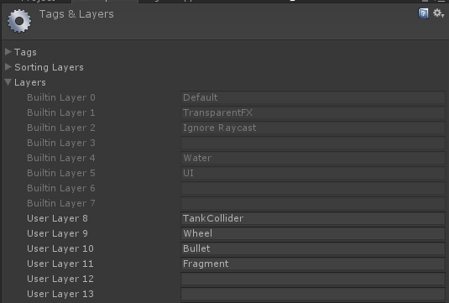

**I used Detonator Explosion Framawork for firing and explosion effects in demo scene. If you want to use their package with this package, you will find “Import These After Detonator Installation.unitypackage” file under Prefabs folder. But first, download and import Detonator Package from here;**

[**http://u3d.as/1qK**](http://u3d.as/1qK)

**Once you have imported the package, then import “Import These After Detonator Installation.unitypackage”. Now you have 2 prefabs i have configurated for firing, and explosion effects. Don’t forget to leave a rating for their work if you like.**

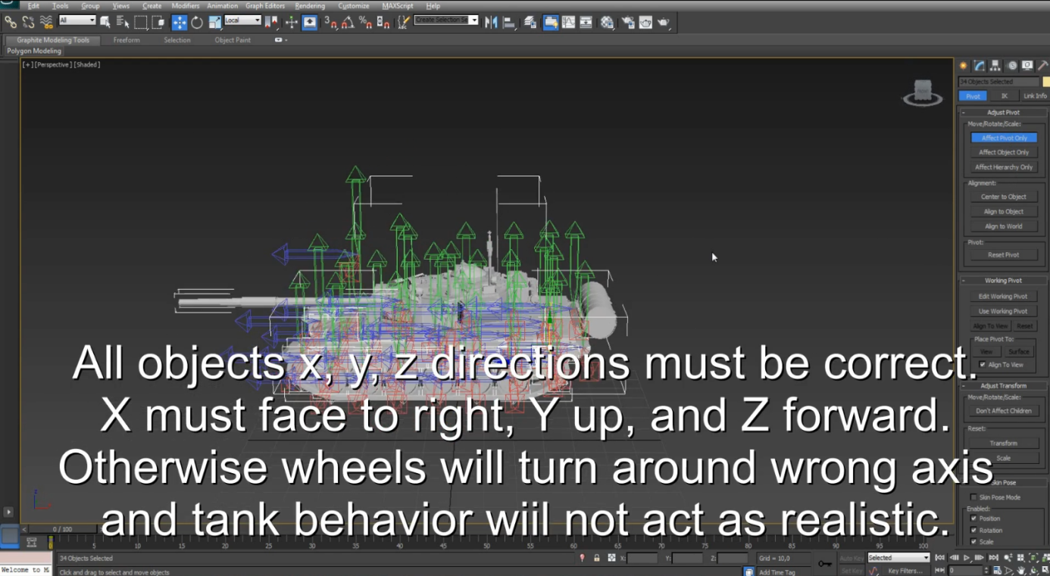

About the Engine Torque Curve:

**Your maximum speed value must be same position with last key of the engine curve value. So, if your vehicle’s maximum speed is 65, your curve’s last key must be at 65 length. Engine will drain torque depends on vehicle speed with this curve.**

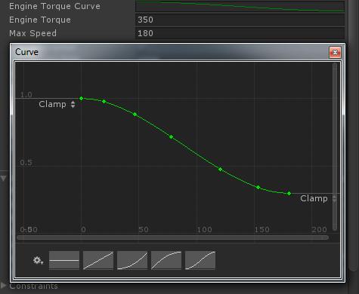

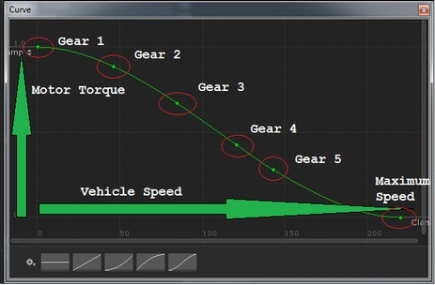

About the Tank Track:

**Track is actually a skinned mesh, and designed in 3ds max modeling software. Each track contains 16 bones. Top side of bones are useless, but you have to create them too for realistic bending.**

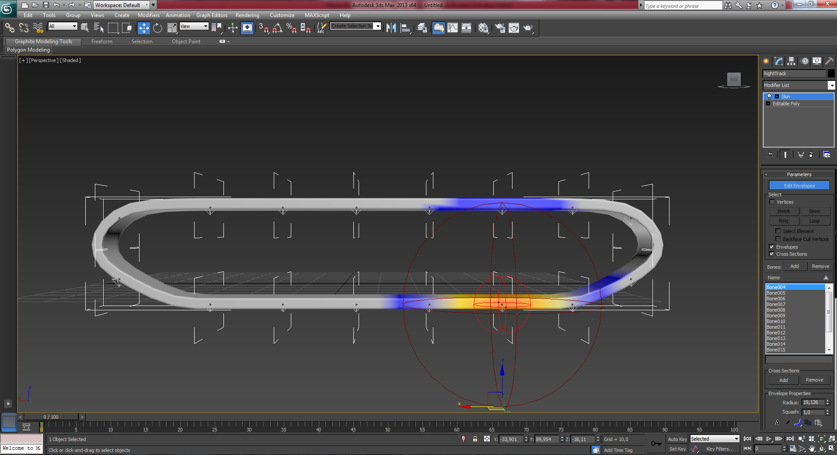

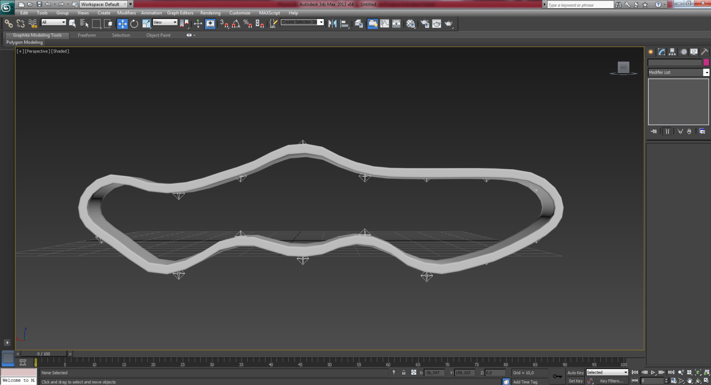

**Buttom side of bones should be exactly at same line with above correspoing wheel like this;**

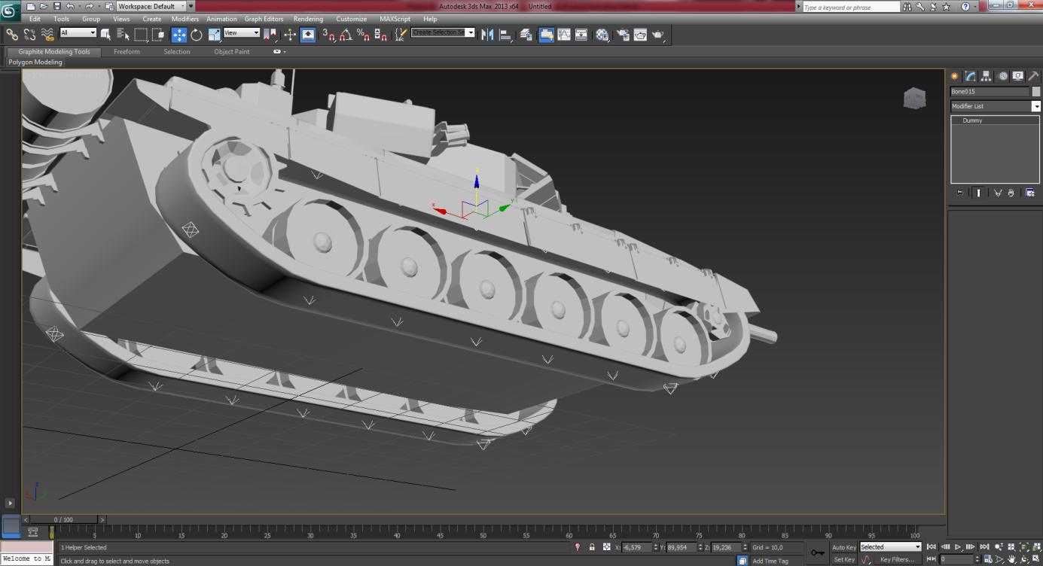

**Package contains preconfigured tank track for 6 wheel vehicles. If you are getting trouble with creating new track for various number of wheel tanks, just contact me.**

How to Setup Your Tank

**This is the tank controller inspector panel;**

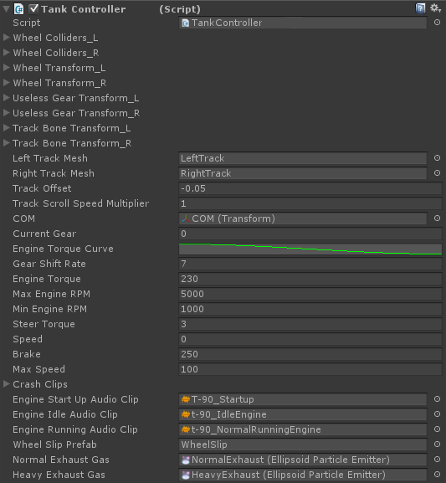

**I highly recommend you to do first, is set your wheel colliders and wheel transforms name properly. E.g. First left wheelcollider’s name is 1L, second left wheelcollider’s name is 2L, third left wheelcollider’s name is 3L...**

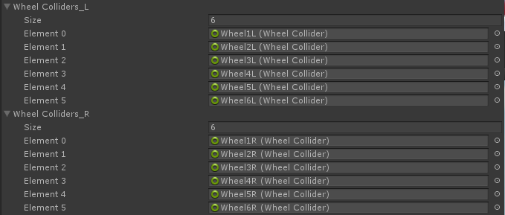

**When your naming is completed, you can simply set your wheel colliders and wheel transforms each left and right side.**

**After wheel setup, you will find useless gear colliders and transforms. Actually, those are gears above wheels, and tense system for tracks. If you don’t have any gears, leave them.**

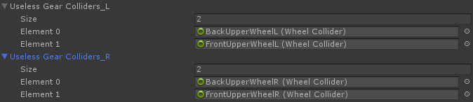

**Now you have to select your track rigs. I included rigged track for the package, i’m not a good designer, but that will do the job . If you want to make your own track model, you have to rig your track nicely. Select each bones for corresponding wheel colliders. If you have 6 wheel colliders on each side, your track model has to 6 bones at buttom of the track, and should be same position(x, z) with your corresponding wheel collider. May sounds like confusing, but it’s pretty easy to do. I will upload a short tutorial to my YouTube for track rigging.**

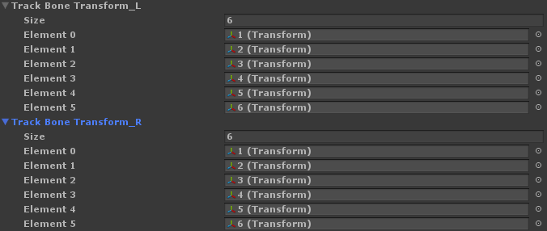

**After done with selecting your track bones, select each track skinned mesh. ( Sorry, i did not name them “Box001” ☺ )**

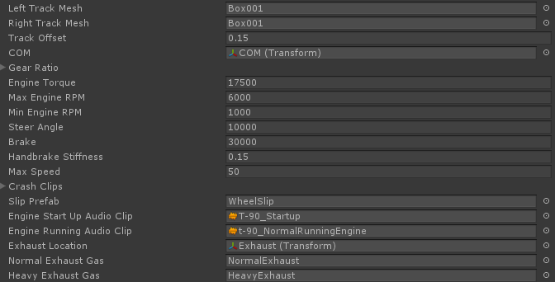

**Select your Center of Mass Transform. If you don’t want to instantiate any smoke, or exhaust gas, just leave them to none.**

How to Setup Your Main Gun

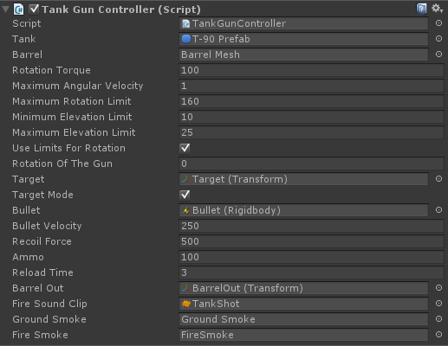

**All settings are clearly understandable i think. Ah, there is one important thing about barrel mesh. Your barrel pivot position must be placed to elbow. Just like this;**

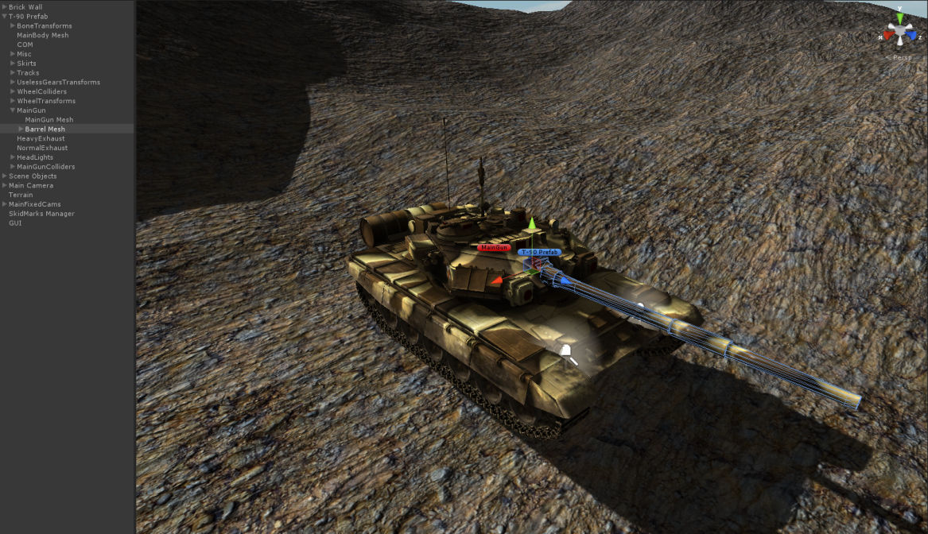

**If you are getting trouble with creating tank setup, just check demo scene and prefabs. If you need to ask anything about package, just e-mail me!**

**Contact: bonecrackergames@gmail.com**